Tier 1 Semiconductor Equipment Company
New Product Introduction – Case Study [front]
Client:
Tier 1 equipment and solutions provider in the semiconductor simulation and test space. The company’s hardware and software products allow engineers to perform stand-alone emulation, in-circuit emulation, and co-modeling of systems on a chip (SoCs).
Facts:
- Annual Revenue: $1 Billion+
- Global Employees: 5,000+
- Global Accounts: 10,000+

Problems:
- Client had deep expertise in software. To broaden the business client acquired a leading edge hardware company with strong R&D capabilities but weak processes.
- Client’s existing product effectively served a customer niche, however, they had challenges with inconsistent product performance, system uptime, and a high level of rework caused by electronic component failures.
Goals:
In addition to the problems, for the next generation product the company wanted to:
- Substantially improve system performance
- Increase system uptime
- Reduce component failures
- Avoid (potentially costly & risky) electronic rework

Expertise:
To improve the structure, co-ordination and focus of the New Product Introduction (NPI) process, PRG provided experienced NPI resources in the following areas:

NPI Project Manager - provided a product life cycle (phase-gate) methodology and core team structure as follows: 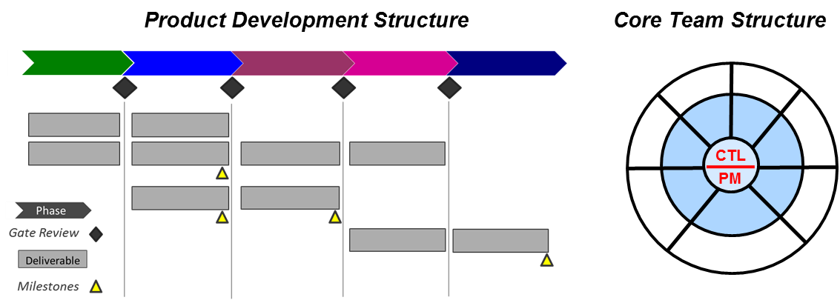
The product life cycle process (provided by the PRG NPI Project Manager) included product development deliverables and checklists tailored to the company’s product and needs.
The core teams included R&D, assembly, test, reliability, quality, supply chain and operations. Mentor core team leaders were assisted with project management tools, training, and expertise provided by PRG to keep the process on-track. Key areas of focus included:
When necessary, PRG’s Project Manager also created and executed integrated project plans and schedules for specific core teams.
Quality expertise was delivered with the following support:

Putting this structure in place resulted in substantial improvement in the quality core team’s ability to identify and track quality issues to closure.
“PRG’s team of experienced engineers and consultants were able to add value to the company on day 1. We didn’t lose time trying to find and then train a team of new employees, saving us time and money. Since our new product has been deployed, the improvement in quality and reliability have been like night and day.”
Senior Director of Operations

(title & headshot)
Design-for-Reliability Expert - analyzed downtime data from the existing system to develop a reliability improvement program as follows:
- Established a reliability benchmark
- Established desired “future state” reliability requirements
- Apportioned reliability targets to subsystems & components
- Created and implemented a reliability improvement plan
- Executed HALT testing for critical subsystems

Results
Product Realization Group leveraged integrated support, introduction of well-defined processes, and collaborative team efforts. Over the course of a year, the client exceeded next generation product & business goals:
- Established a robust New Product Introduction (NPI) process
- Improved system performance
- Increased system uptime
- Reduced electronic component failures & greater reliability
- Exceeded sales and profitability targets

